Player Registration

Player Registration Options
- Login – for those who registered before or where a captain or board member, you can use your login credentials to start the process
- Player Search – Alternatively, you can use the player search option to find yourself
- New Players – if you have never played in any of the leagues covered by this website and therefore are not in the system, please contact Sandy Johnson at 201-739-4613 or sjccsinc@aol.com to get set up.

Register by Loggin In
- Login using your ID and password
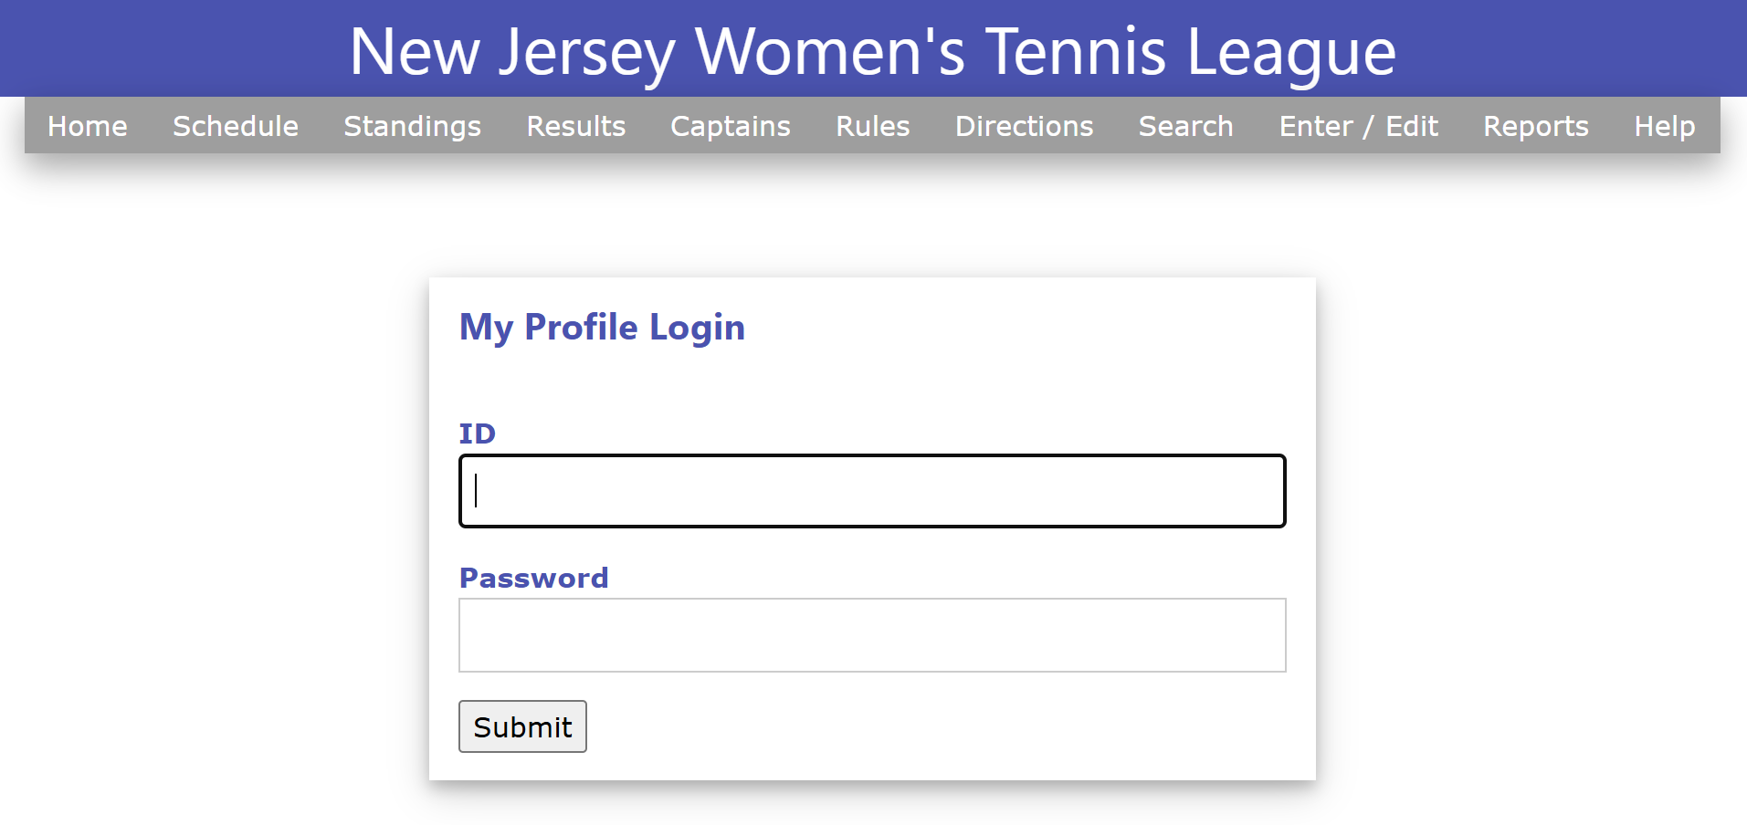

- After logging in, you will be presented with a couple of options depending upon whether you have registered in the past and / or registered this year. This screen shot shows the option if you haven’t registered yet this year.
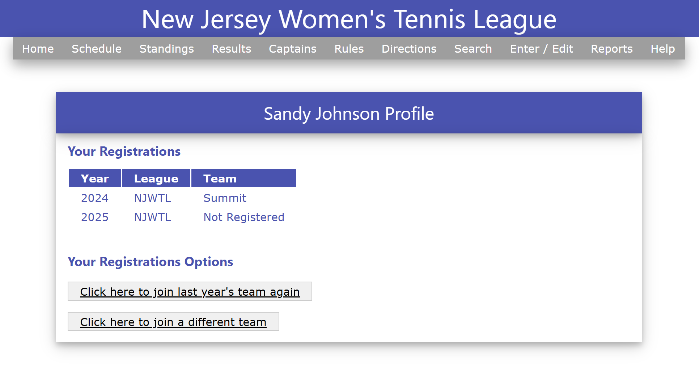
The next screen shows what happens if you have already registered this year. The system knows you have already registered on a team, so it won’t allow you to do it again.
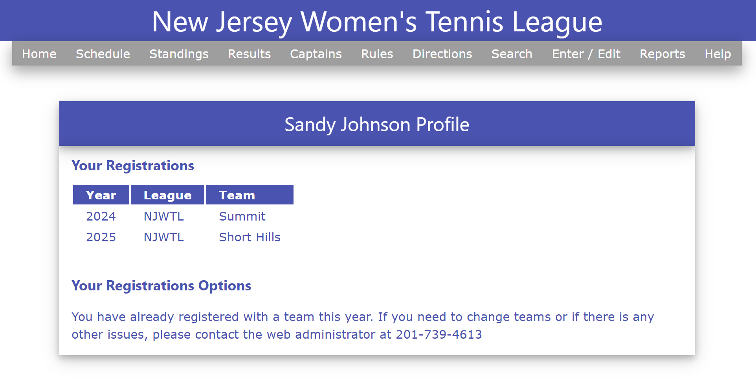
Note:
From here, you can jump down to step 5 which starts the team selection and payment steps. Those steps apply whether you started with the Player Search method or simply logged in.
Register Using the Player Search Method
- Enter your last name and click the Find Player button.
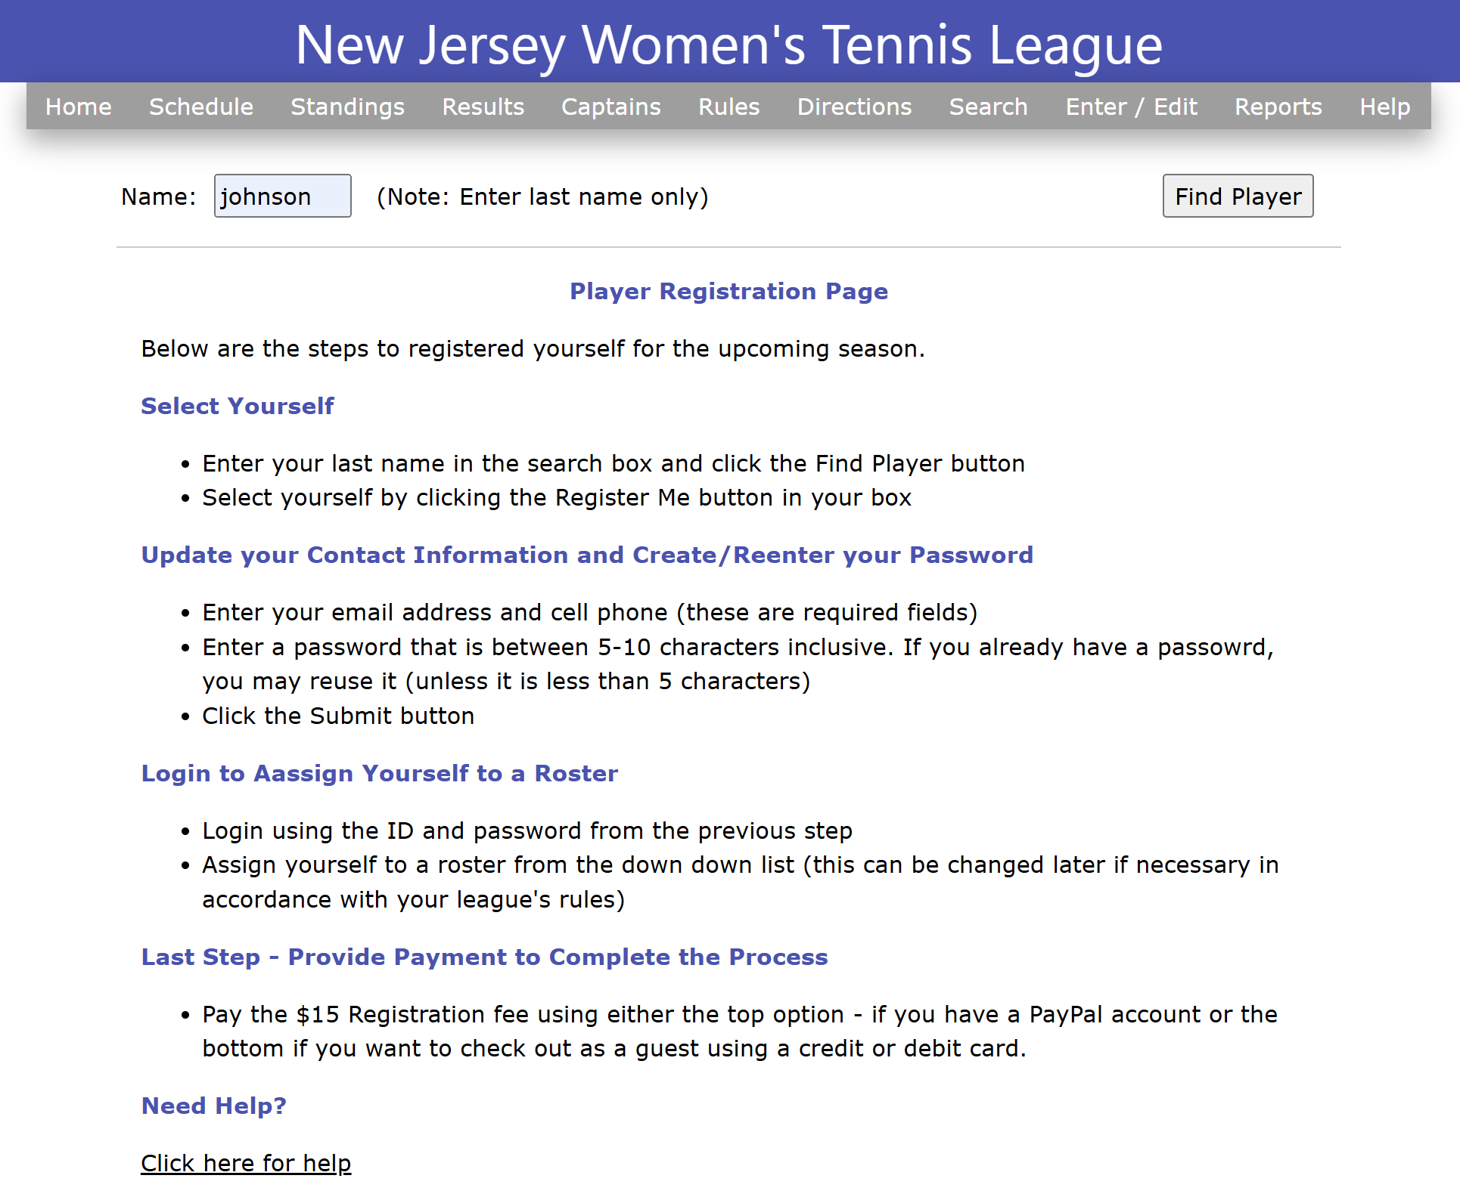

- Scroll down and find your name and click the Register Me button within your box.
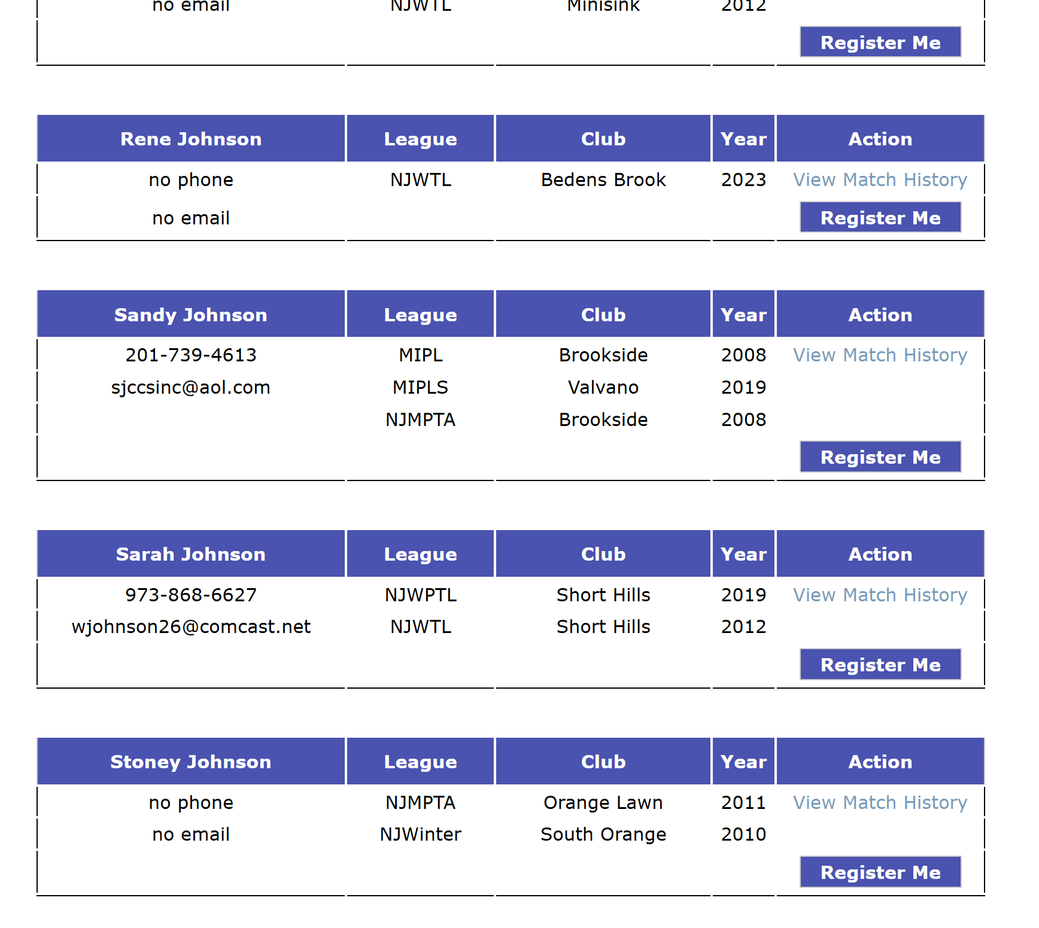
- Enter your phone and email address. Also, enter a password. You may reuse the previous one. Finally, click submit.
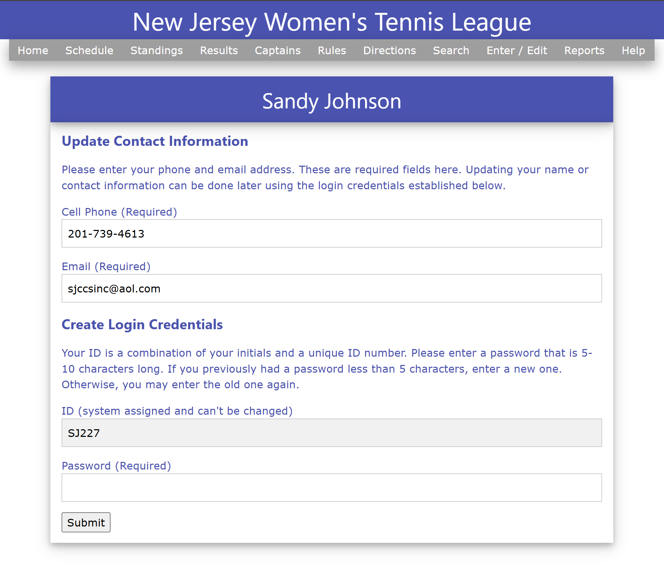

- Enter your ID and password from the prior step and click submit.
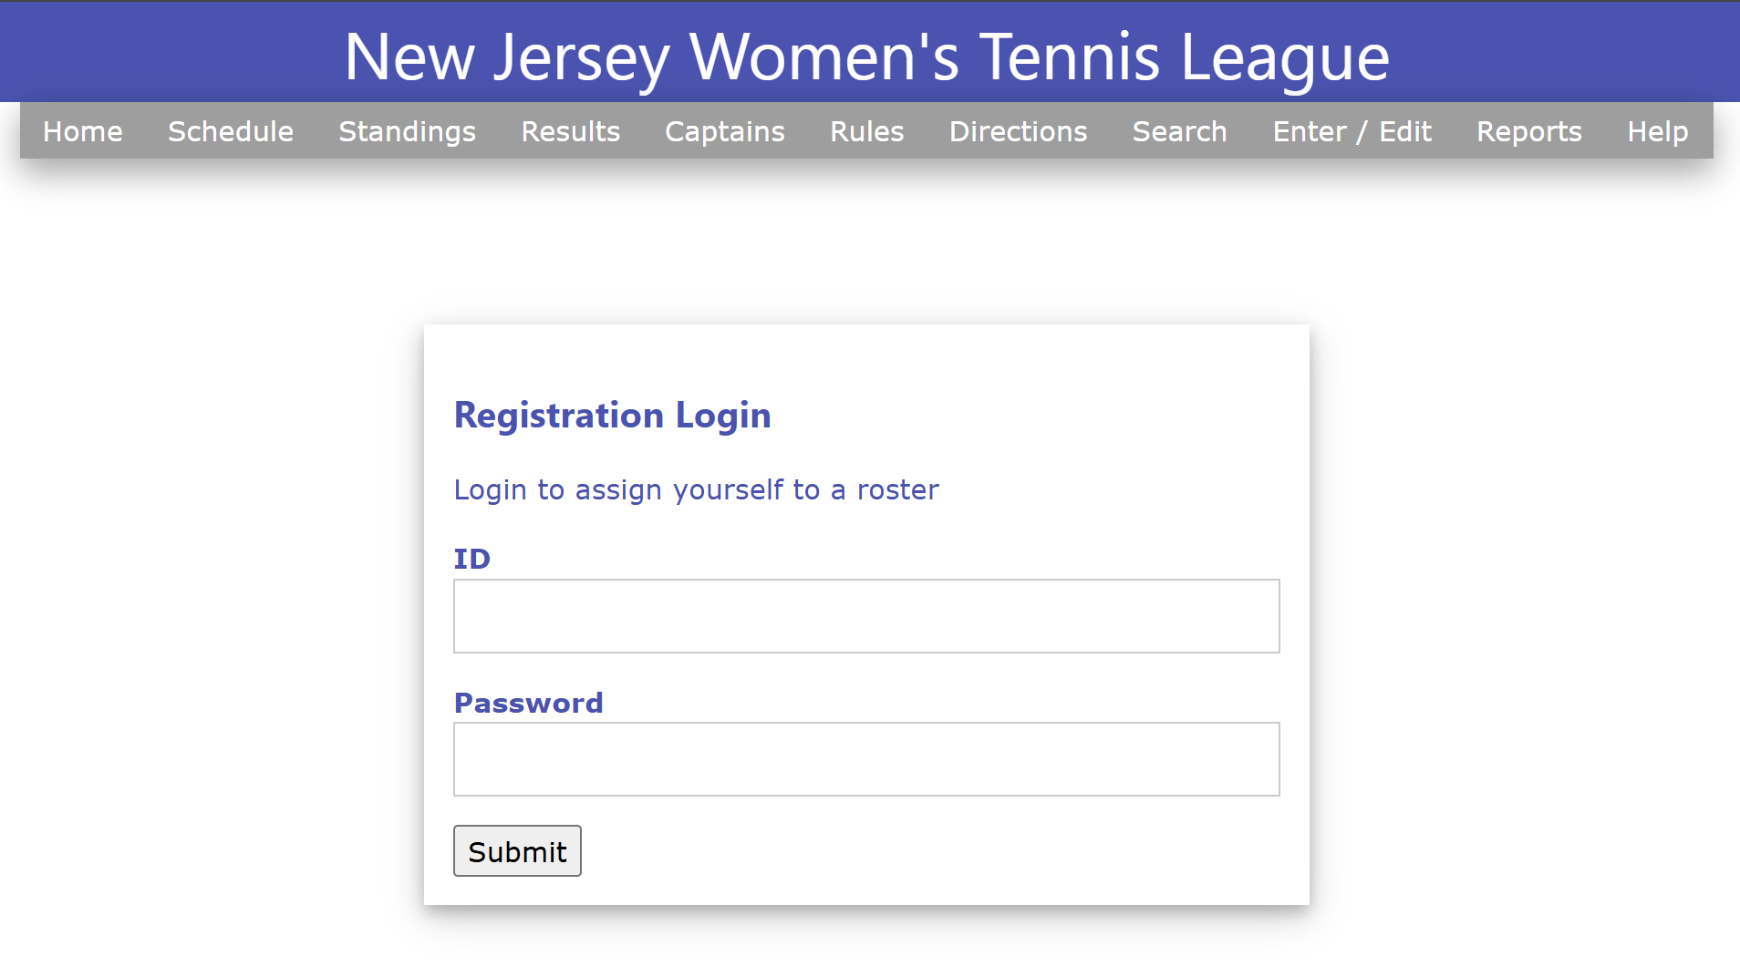

Team Selection
- Select a team’s roster to which to add yourself and confirm your choice when prompted.
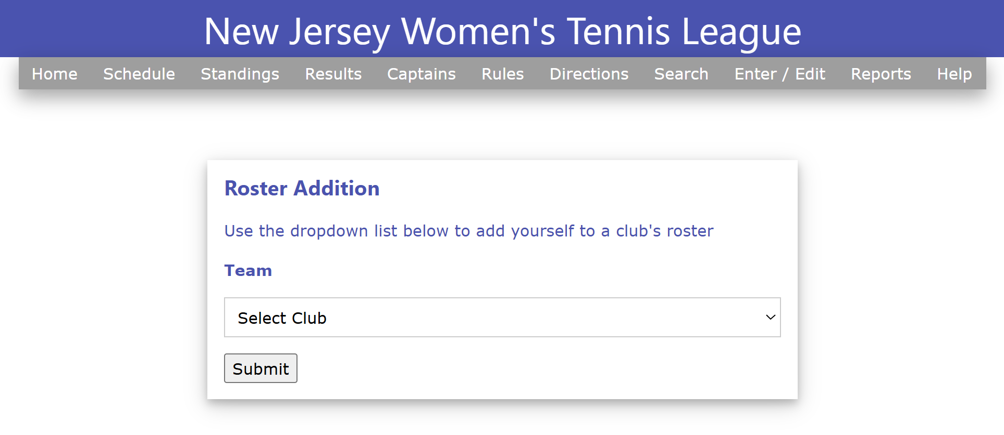

- Now click next to continue to the payment step.
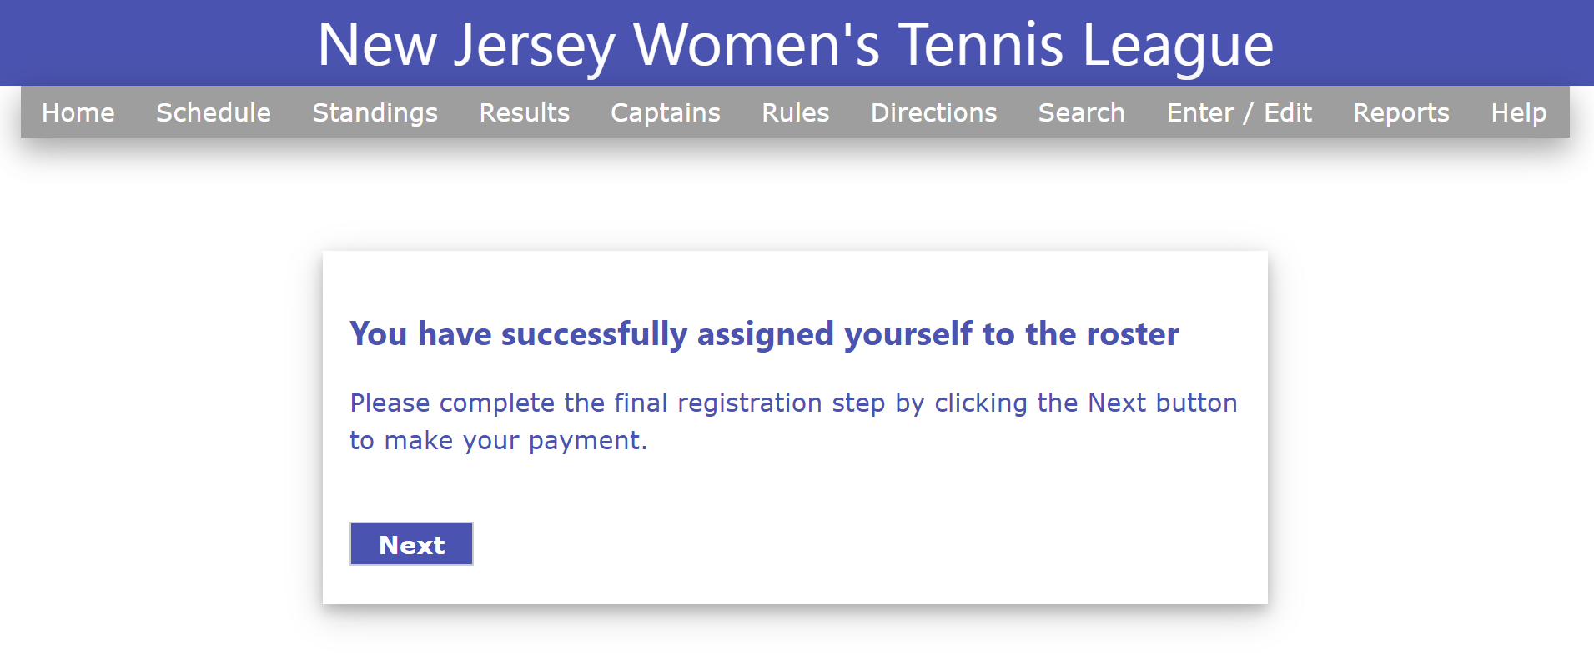

Payment Process
- First, click the check box to acknowledge that the registration fee is not refundable, then click the button to be take to the secure payment widnow.
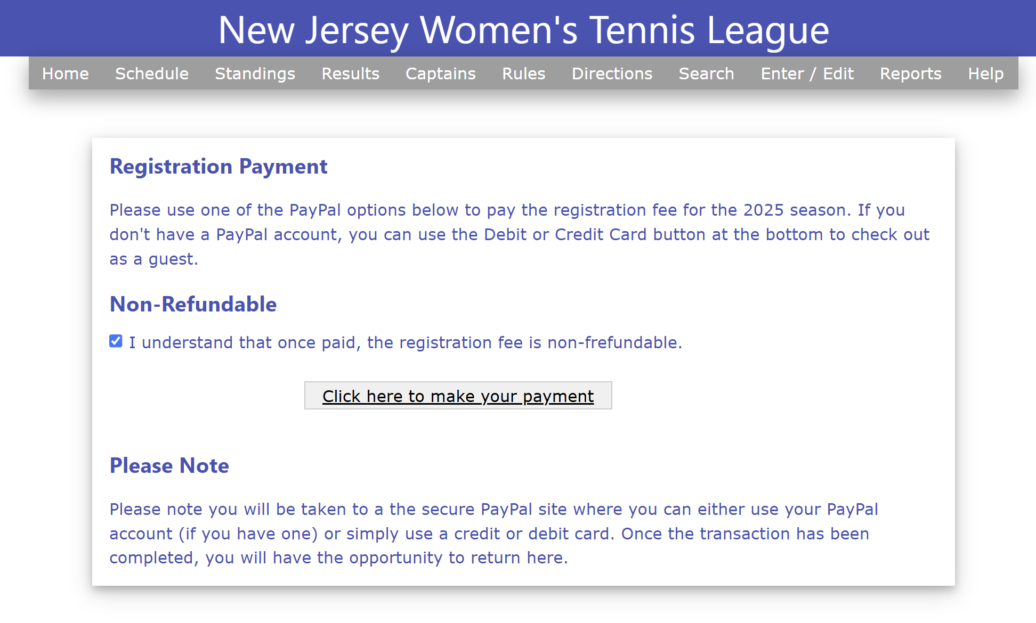

- Use either option on the right to make your payment
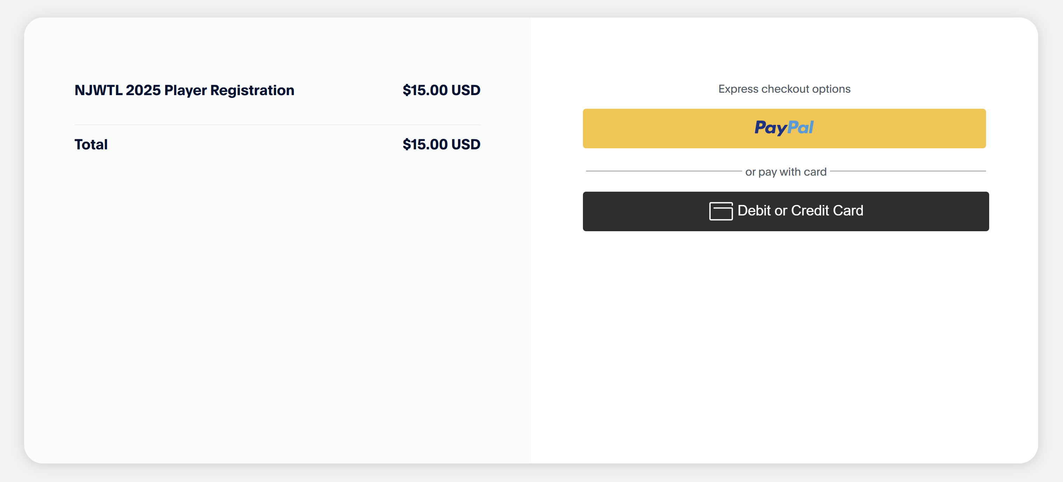

- Once the payment has been made, you will get this PayPal screen.
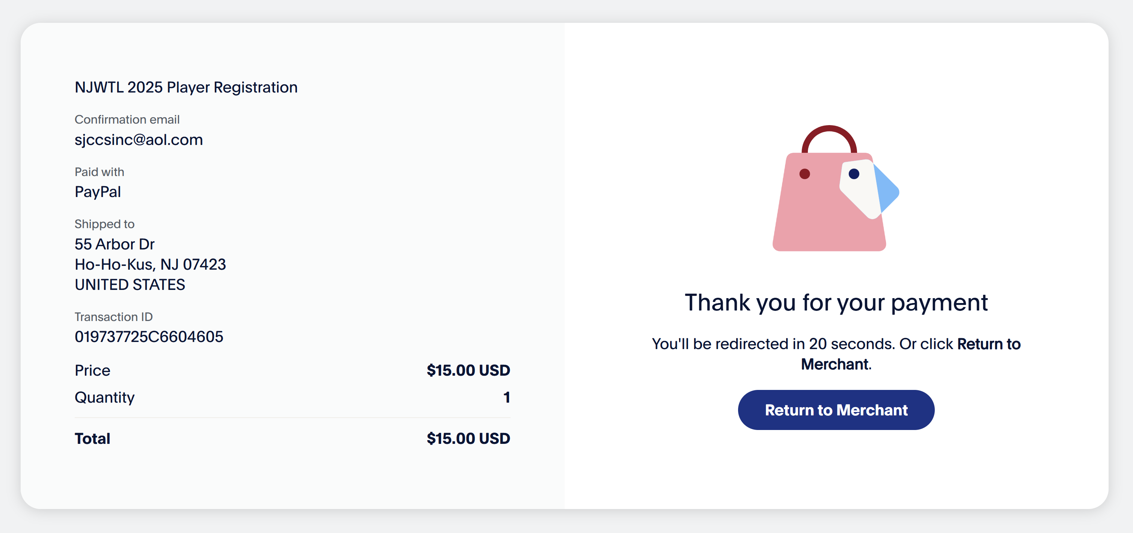

- And finally, you can click the Return to Merchant button or it will automatically bring you back.

