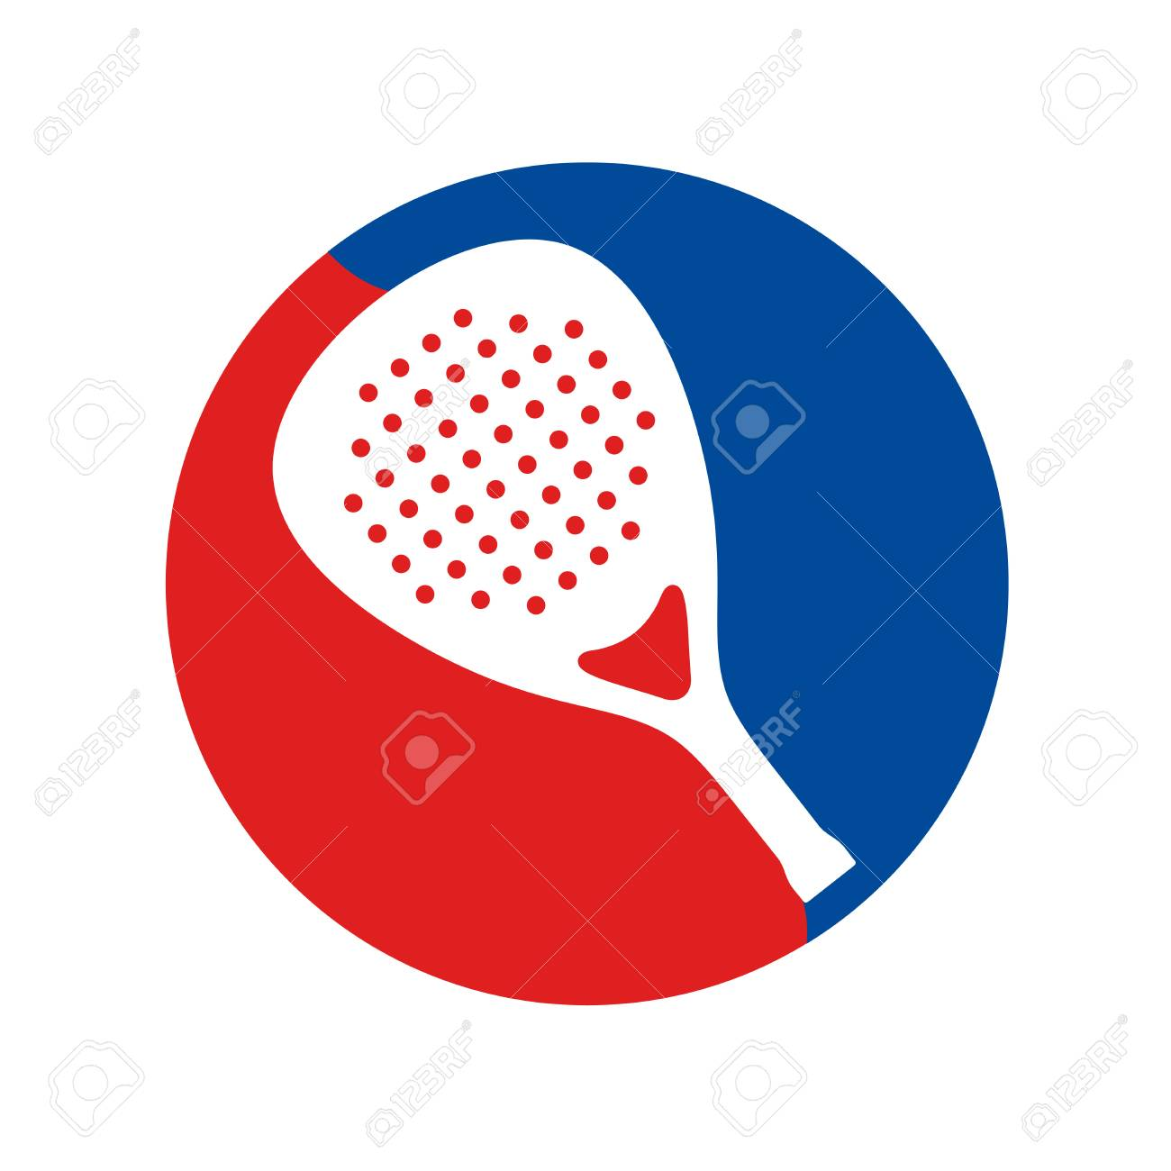
2022-23
LADIES SHORE PADDLE TENNIS LEAGUE
PLAYERS SHEET FOR MATCHES

Date of Match:

Home Team: Visiting Team:

Court 1 Court 1
Player 1 Player 1
Player 2 Player 2

Court 2 Court 2
Player 1 Player 1
Player 2 Player 2

Court 3 Court 3
Player 1 Player 1
Player 2 Player 2

Court 4 Court 4
Player 1 Player 1
Player 2 Player 2

RESULTS
Court 1 Score: Won By:
Court 2 Score: Won By:
Court 3 Score: Won By:
Court 4 Score: Won By:

Total matches won today by Home Team:

Please email results to: Betsy Nelson: dbcsojt@aol.com

