Fall 202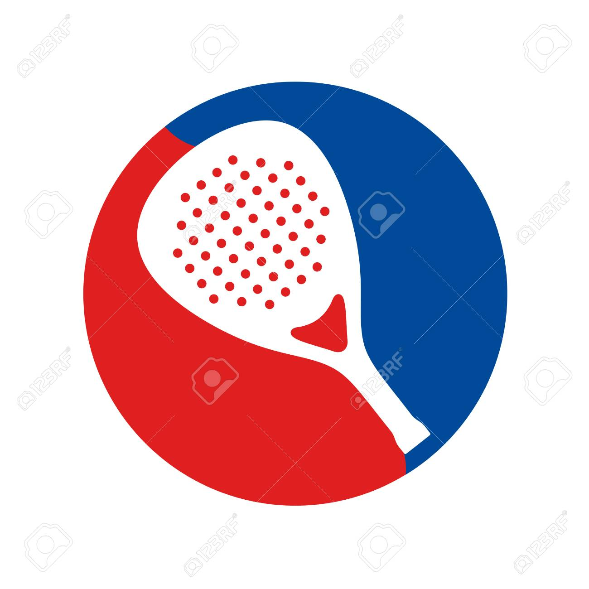5

LADIES SHORE PADDLE TENNIS LEAGUE

PLAYERS SHEET FOR MATCHES

Date of Match: ______

Home Team: Visiting Team: __

**Court 1**

Player 1 Player 1 __

Player 2 Player 2 __

**Court 2**

Player 1 Player 1 __

Player 2 Player 2 __

**Court 3**

Player 1 Player 1 __

Player 2 Player 2 __

**Court 4**

Player 1 Player 1 __

Player 2 Player 2 __

**RESULTS**

Court 1 Score: Won By:

Court 2 Score: Won By:

Court 3 Score: Won By:

Court 4 Score: Won By:

Total matches won today by Home Team:

Please email results to Gail Van Winkle, [gailfvw@gmail.com](mailto:gailfvw@gmail.com)